Xpath Assignments
Assignment I: Write xpath for below elements using below html webpage screenshot & html
- Textbox (large one)

- //textarea[@ id=’textBox’]
- //textarea[text()=’border: thin solid black’]
- //*[@textarea id=’textBox’]

- Button (Test Xpath)

- //p[@value=’Test XPath’]
- //p[text()=’doTest’]
- //p[contains(@input type, 'button')]

- Label with text Paragraph one

- //p[2]
- //p
- //p[@text()=’ Paragraph one’]

- Label with text Paragraph two

- //p[@id=’two’]
- //p[3]
- //p

- 2nd element of list i.e. List item two

- //ul/li[2]
- //ul/li[@text()=’two’]
- //li/parent::ul/child::li[2]

6.Textbox with value XpathHere

- //p[@value= ‘XpathHere’]
- //p[text()=’ XpathHere]
- //p[contains(@value, 'button')]
- //*[@value= XpathHere’]

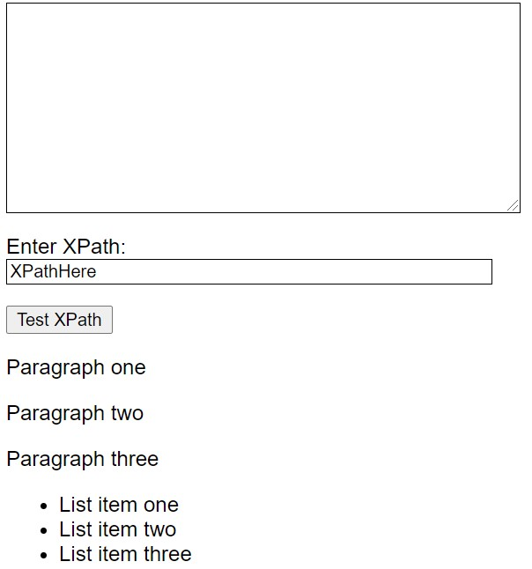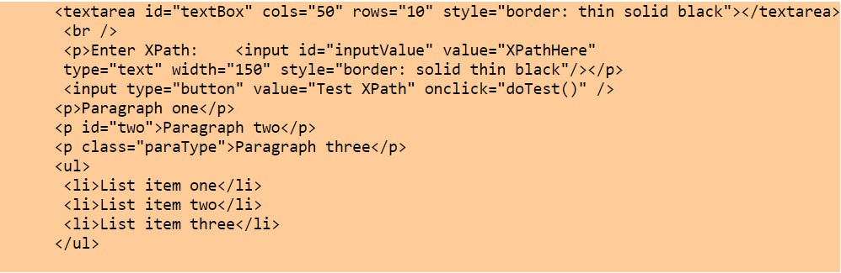
6.

Textbox with value XpathHere

Note: Write at least 3
-
xpaths for above
4

HTML Code :

MSSquare Technologies

Assignment II:
Consider the following HTML code snippet

<
table
>

>
<
tr

td>3</td
<
>

<
td>4</td
>

<
/tr
>

<
tr
>

td>1</td
>
<

<
td id=”Test”>MSSquare</td
>

<
td>2</td
>

<
/tr
>

<
/table
>

a.

Below xpath is pointing to which text field?

//table/tr[1]/td td>3</td

b.

Write
at least 3
X
path
s

for value 2 (using relative xpath of id=test)

- //table//td[@id=’Test’]/following-sibling::td
- //td[@id=‘Test’]/parent::tr[2]/parent::table/child::td[3] wrong
- //td[@id=’Test’]/. ->
- //td[@id=’Test’]/ following-sibling::td

